
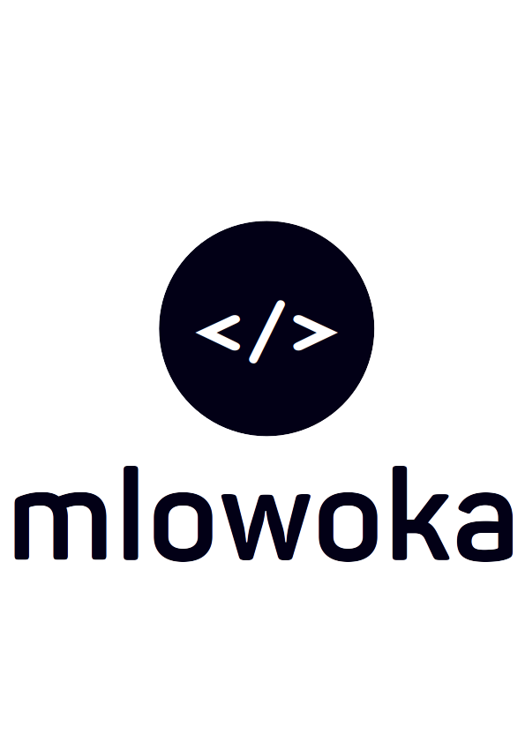
MCOMAT SYSTEM

MEMO NO. 1001

To: Administrator
From: John Kabatika Chirwa (Software Engineer)
Date: 30^{h} January, 2024
Subject: SCRUM MEETING ON STUDENT ACADEMIC INCREMENT REQUIREMENTS REFINEMENT

I write this memo to request a meeting tomorrow, 31st January 2024, at 1630 concerning the MCOMAT system being developed. The MCOMAT System is an information system currently only deploying student tasks in the academics section currently...

Regards:
John Kabatika Chirwa
(Software Engineer)

CC: Registrar
Dean of Academics
Director

